CONCEPT PAPER FROM THE MAKEALTH TEAM ABOUT THE INCUBOX
PROBLEM STATEMENT
According to the World Health Organization, an estimate of 15 million babies are born too early. That is 1 in every 10 babies born. The survivors often face a lifetime of disability, including learning disabilities and visual and hearing problems. Globally, prematurity is the leading cause of death in children under the age of 5. And in almost all countries with reliable data, preterm birth rates are increasing.
Inequalities in survival rates around the world are stark. In low-income status countries, like Uganda half of the babies born at or below 32 weeks (2 months early) die due to a lack of feasible, cost-effective care, such as warmth, breastfeeding support, and basic care for infections and breathing difficulties. In high-income countries, almost all of these babies survive.
Gulu Hospital had no incubator, till 2016 when only 5 incubators were donated by Non-Government Organizations such as Voluntary Service Overseas. Acholi mothers have continuously competed for these 5 incubators with their counterparts from Lango, West Nile and parts of South Sudan.
SOLUTION DESCRIPTION
As the Makealth team of six First Year Students of Makerere University, we came with an idea of the Incubox that will be a Portable Neonatal Incubator.
It is a mother’s basket that will provide warmth to the baby lied in it because the prematurely born baby has body organs that are not yet fully developed so requires to maintain a temperature in the range of 36-38 ⁰C by using a microcontroller that uses a temperature sensor to monitor the temperature inside the incubox and uses the relay switch to automatically switch off the bulb that provides the warmth to the baby
It also will be able to add humidity to the baby since evaporative water loss is the most important channel of heat loss due to inadequate keratinization of the baby’s skin.
It will be more affordable and more portable for transportation to hospitals that have facilities with better facilities.
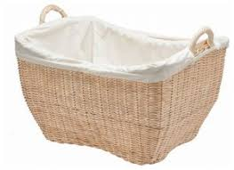 | 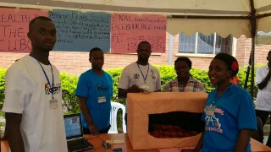
The prospected Incubox | The most current prototype of the Incubox

Our Target Market include;
- Every mother who has a premature birth of a baby is a potential customer of buying the Incubox.
- Different health Clinics and ambulances of different hospitals will purchase incuboxes for their patients because it will be more affordable and portable for transportation to hospitals that have the permanent incubators.
- Non-Government Organisations like USAID that are committed to improving child and maternal health, the World Health Organization because it is committed to reducing the health problems and lives lost as a result of preterm birth. Hence they would purchase Incuboxes for different low-income setting hospitals in countries.

The Incubox will greatly save the lives of many great ladies and Gentlemen that didn’t receive a chance to celebrate their first birthday due to failure to access neonatal incubators after being born prematurely.
CONTACTS:
e-mail- makealth@gmail.com
Facebook-Makealth team
Twitter-@Makealth Team

http://www.who.int/mediacentre/factsheets/fs363/en/
www.allafrica.com/stories

