Photo | 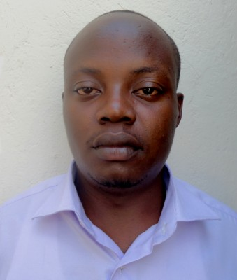
Name | Nantagya Donald S
Department | DIAAD
Designation | Assistant Lecturer
Courses Taught | Textile structural design,Design elements,Black and white design,Research
Research interests | Crafts and cultural themes
Telephone | 256703920118/0772994106
Office Number | Kingdon house
Email | nantagya@sifa.mak.ac.ug

Photo | 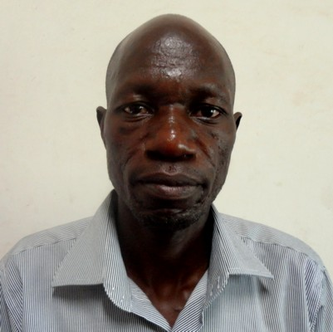
Name | Mubiita Stephen
Department | DFA
Designation | Assistant Lecturer
Courses Taught | Art History(Core & Elective)
Research interests | Uganda’s Contemporary Art. Urban Art(Monuments)vs Cultural preservation
Telephone | 256772551004
Office Number | Costable Close
Email | smubiita@cedat.mak.ac.ug

Photo | 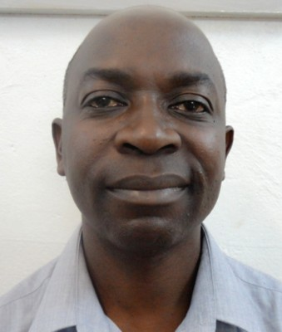
Name | Assoc. Prof. George Kyeyune
Department | DIAAD
Designation | Assoc.Prof
Courses Taught | Sculpture and History of African Art
Research interests | Contemporary Art in Uganda,metal casting technology
Telephone | 256772325320
Office Number
Email | gwskyeyune@gmail.com

Photo | 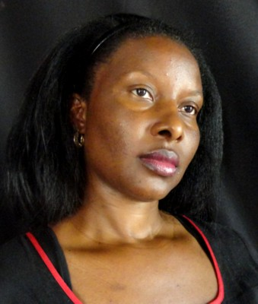
Name | Dr. Amanda Tumusiime
Department | DVCDM
Designation | Lecturer
Courses Taught | Art History, Drawing, Research, major work, cultural studies
Research interests | Art and Gender, Art history and feminism, gender and politics, cultural studies, painting and drawing
Telephone | 256782884420/0702884420
Office Number
Email | tumusiimeamanda@gmail.com  tumusiimeamanda@cedat.mak.ac.ug

Photo | 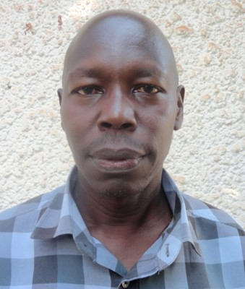
Name | Ifee Francis Xavier
Department | DFA
Designation | Senior Lecturer
Courses Taught | Oil painting and water colour painting
Research interests | Cultural themes
Telephone | 256772410353
Office Number | Kingdon house
Email | ifeefrancis@yahoo.co.uk

Photo | 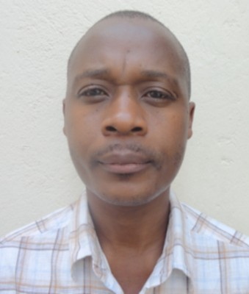
Name | Kizito Fred Kakinda
Department | Visual communication
Designation | Assistant Lecturer
Courses Taught | Drawing,Painting & Research methods
Research interests | Arts in health care,Art therapy & Anthopology
Telephone | 256772406755/256714406755
Office Number | Kingdon house
Email | fkkakinda@yahoo.com

Photo | 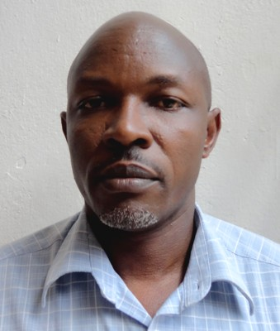
Name | Kanuge John Bosco
Department | DVCDM
Designation | Lecturer
Courses Taught | Major work, Research, Print making & illustration
Research interests | Word and image relationships,visual/verbal relashionships & contexts
Telephone | 256772484740
Office Number | Printing studio
Email | jbkanuge@cedat.mak.ac.ug

Photo | 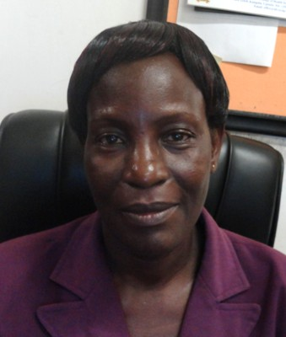
Name | Edith Lutwama
Department | Library
Designation | Librarian
Courses Taught | Information Science
Research interests | Information science
Telephone | 256772558762
Office Number | Library
Email | elutwama@mulib.mak.ac.ug

Photo
Name | Banadda Godfrey
Department | Visual communication
Designation | Lecturer
Courses Taught | Painting:Oil colour,water colour,visual arts
Research interests | Semiotics in visual arts
Telephone | 256772461073
Office Number | Printig studio
Email | Banaddag_imgs@yahoo.com

Photo | 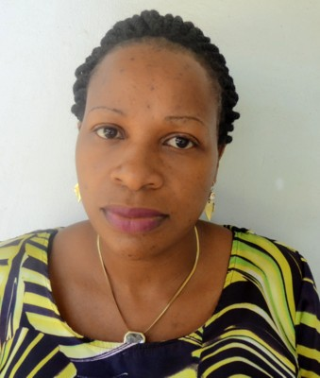
Name | Kasozi Dorah Kalule
Department | IAAD
Designation | Assistant Lecturer
Courses Taught | Jewelery design,design elements and research methods
Research interests | Design innovations,Local resource materials management and utilization
Telephone | 256773181669
Office Number | Kingdon house
Email | kasozi@cedat.mak.ac.ug

Photo
Name | Lubowa Paul
Department | VCDM
Designation | Lecturer
Courses Taught | Illustration,design computing, design elements, major work projects
Research interests | Visual communication for social transformation, Instructional illustration for social development/innovation
Telephone | 256772468292
Office Number | Design/Printing studio
Email | lubpa@sifa.mak.ac.ug  paullubowa@gmail.com

Photo | 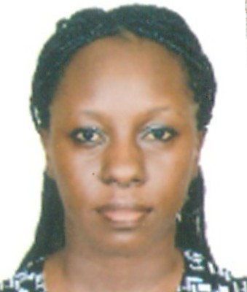
Name | Esther Ndagire Kavuma
Department | IAAD
Designation | Assistant Lecturer
Courses Taught | Textile Design and technology, Typography design elements
Research interests | Art in medicine/health, Art, Design, Architecture collaboration in urban design
Telephone | 256772648102
Office Number | Kingdon house
Email | ndagenda@cedat.mak.ac.ug

Photo | 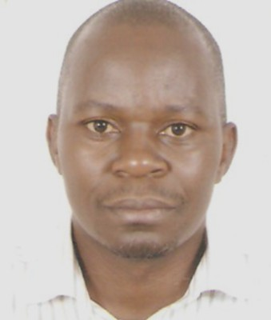
Name | Sserunjogi Patrick
Department | VCDM
Designation | Assistant Lecturer
Courses Taught | Design computing, design elements, advertising design
Research interests | Design and user values
Telephone | 256752648178
Office Number
Email | psserunjogi@cedat.mak.ac.ug

Photo
Name | Angelo Kakande
Department | DIAAD
Designation | Senior Lecturer& Chair
Courses Taught | Art history, Ceramics, History of fashion
Research interests | Art & Politics, Human Rights and the law
Telephone | 256772590361
Office Number | Design studio
Email | angelo@cedat.mak.ac .ug

Photo
Name | Balaba Edward
Department | DFA
Designation | Assistant Lecturer
Courses Taught | Drawing, Ceramics, sculpture fabrication
Research interests | Ceramics/refractory material, Arts and health/Arts in medicine
Telephone | 256782306320
Office Number | Ceramics building
Email | balaba22@gmail.com

Photo | 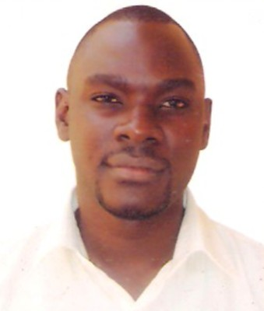
Name | Kizito Abbey
Department | DFA
Designation | Assistant Lecturer
Courses Taught | Oil painting, water colour painting, drawing,com. design
Research interests | Art and gender, art and design and the effect of technology
Telephone | 256772437482
Office Number | Kingdon house
Email | kattoabbey@yahoo.com  abbeykatto@cedat.mak.ac.ug

Photo | 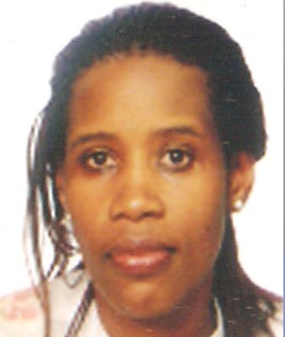
Name | Nakisanze Sarah
Department | DIAAD
Designation | Assistant Lecturer
Courses Taught | Fashon design, research
Research interests | Production management, North and South SME trade relations
Telephone | 256772439767
Office Number | Kingdon house
Email | nakisanze@cedat.mak.ac.ug

Photo
Name | Annete Sebba
Department | DVCDM
Designation | Lecturer
Courses Taught | Photography, design communication
Research interests | Visual communication, gender violence, design and ICT
Telephone | 256701107311
Office Number | Kingdon house
Email | sebba@cedat.mak.ac.ug

Photo
Name | Nsereko Joseph Raymond
Department | DVCDM
Designation | Lecturer
Courses Taught | Design communication, advertising design
Research interests | Product design, Industrial design
Telephone | 256776833712
Office Number
Email | njray@cedat.mak.ac.ug

Photo | 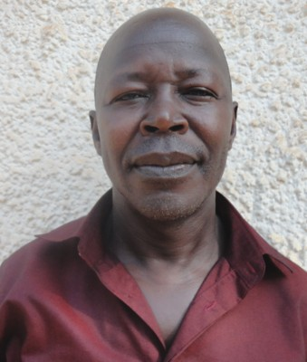
Name | Odama Jacob
Department | DFA
Designation | Lecturer
Courses Taught | Paintig anatomy
Research interests | Research in potraiture
Telephone | 256772575065
Office Number
Email | odamajacob@gmail.com

Photo | 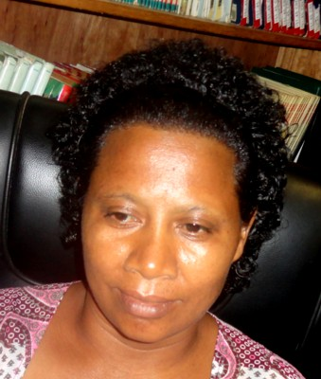
Name | Nuwamanya Annet Kibajjo
Department | Library
Designation | librarian
Courses Taught
Research interests
Telephone | 256712251188
Office Number | library
Email | ankibajjo@mulib.mak.ac.ug

Photo | 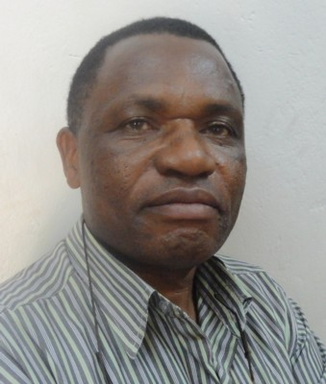
Name | Sserunkuma Bruno
Department | DIAAD
Designation | Lecturer
Courses Taught | Ceramics, Research,drawing, exhibition
Research interests | Art and crafts industry, pottery and ceramics materials, culture and society
Telephone | 256772498684
Office Number | Ceramics building
Email | brunosse@yahoo.com  brunosse@cedat.mak.ac.ug

Photo | 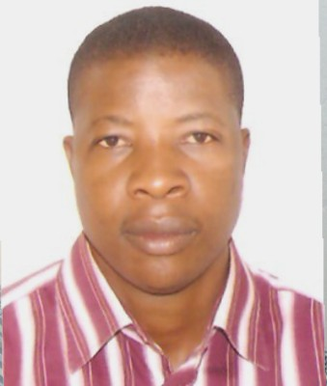
Name | Ssewanyana Robert
Department | DIAAD
Designation | Assistant Lecturer
Courses Taught | Sculpture fabrication/Drawing
Research interests | Applied sculpture
Telephone | 256772413507
Office Number | Kingdon Annex
Email | Ssewanyanarobert@yahoo.com

Photo | 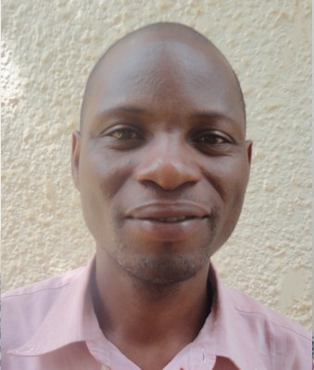
Name | Tusiime Mathias
Department | DVCM
Designation | Grounds man
Courses Taught
Research interests | Art, special canvas making, arts in health, skill development and recycling
Telephone | 256752533122
Office Number
Email | tusiimemath@yahoo.co.uk

