DIGI CHILD PROJECT PRESENTATION WRITE UP

Digi child is an innovative community outreach project that is carried out by engineering students at CEDAT. It involves teaching the young generation in primary and secondary schools digital skills of computing and programing using scratch programing language.

Back ground.
The DIGI child project arose as a result of the AFRICA code week program that is run by the IRISH embassy along with the students at CEDAT, which happens every October of the year and was initiated in 2016. It involved training students within the college scratch programming, and were later sent to schools to teach programing. The school children were really amazed to learn new skills and create innovative work that aids their learning.

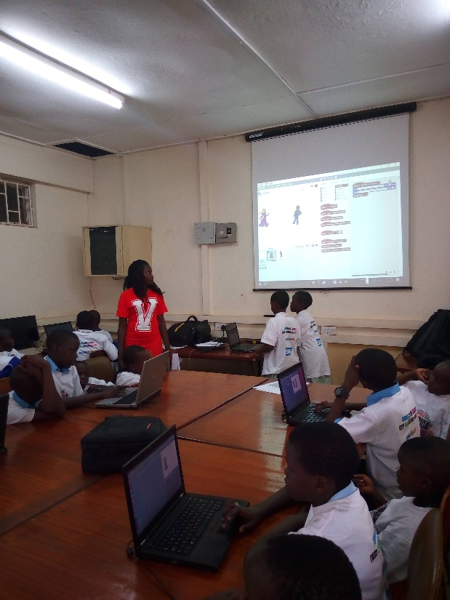

Benefitiaries of the project
- Primary schools.
- Secondary schools
- Vocational institutes.

What is Scratch?
Scratch is a programming language developed at the MIT Media Lab in the United States that has captured the imagination of children everywhere.
Scratch makes it easy for users to create their own interactive stories, animations, games, music, art and to share these creations on the web.

Scratch combines youthful creativity and curiosity with school subjects such as mathematics and art in a vibrant digital environment that allows children to become adopted to computer coding in such a short period of time that you will truly be astonished.
So it is ideal for children aged eight to eleven years of age.
Scratch A Fun Way of Learning
The Scratch language has similarities to children’s building brick toys. It uses a simple structure of graphical bricks or blocks of computer code that snap and interlock together to build and control sound, music and images. Hence it is ideally suited for the enjoyment and learning by children, as it utilizes their natural inclination of thinking with building materials to create different shapes, games and stories within a new and exciting interactive digital dimension. Scratch interface.
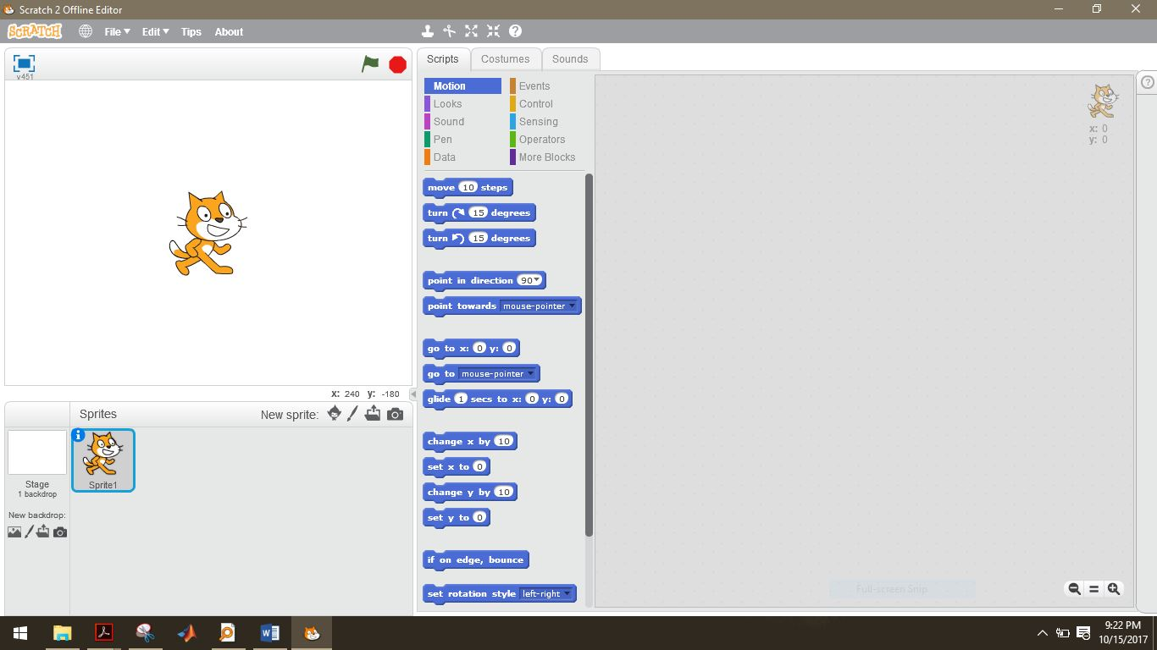

Educational Benefits: Numeracy, Literacy & Beyond
Scratch provides a unique environment for children and young people to develop and utilize their artistic and creative talents through the construction of eye-catching animations.
During the training sessions, children work together to complete certain projects, learn to plan, design and share tasks, are encouraged to show and explain their completed works to their fellow participants where critical analysis and compliments by fellow classmates are an integral part of the learning presentation and communication process.
Scratch allows children to develop their artistic and creative skills in a digital world that is both empowering and adventurous.
The teaching of Scratch utilizes so many different aspects of junior school curricula, not just art -but also languages, science and particularly numeracy and literacy.

Sample weather project in scratch

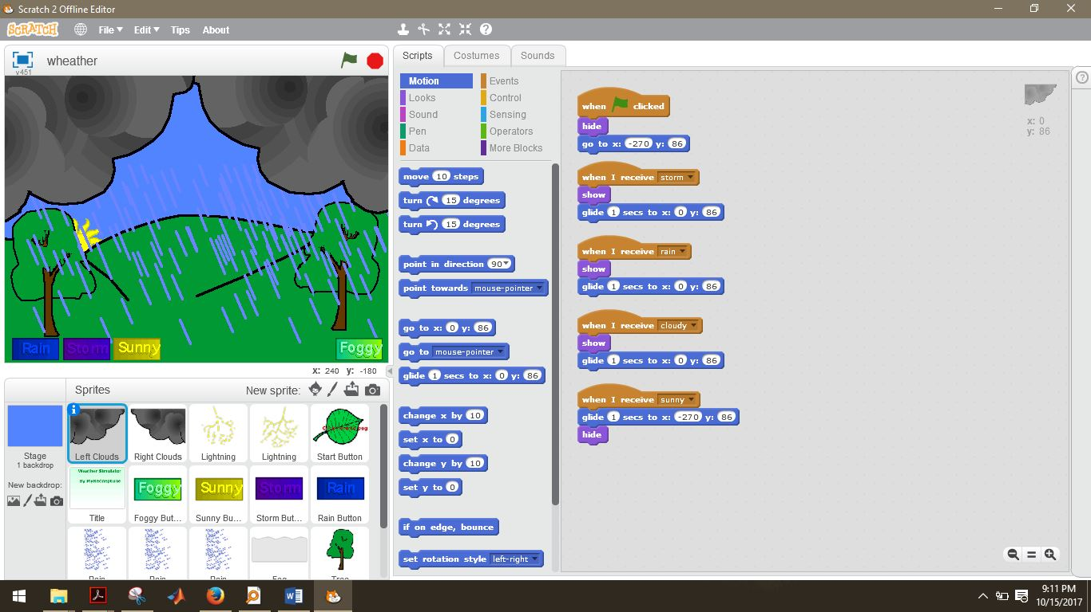
PROJECT IMPLEMEMNTATION PROCEDURE.
- Train trainers ie university students.
- Send the trainers to various primary and secondary in the country schools with or without computer labs.

PRESENTERS FOR THE DIGI CHILD PROJECT AT THE CEDAT OPENDAY 2017
Digi child
Promoting early childhood learning in digital skills
Kabamba Margaret | 0779820362
Nambi Joan | 0758744543
Nanyonjo Jovia Margaret | 0785259687
Brenda Tugume | 0757612154
Njolima Concepta | 0776741890
Mirembe Betty | 0781873556

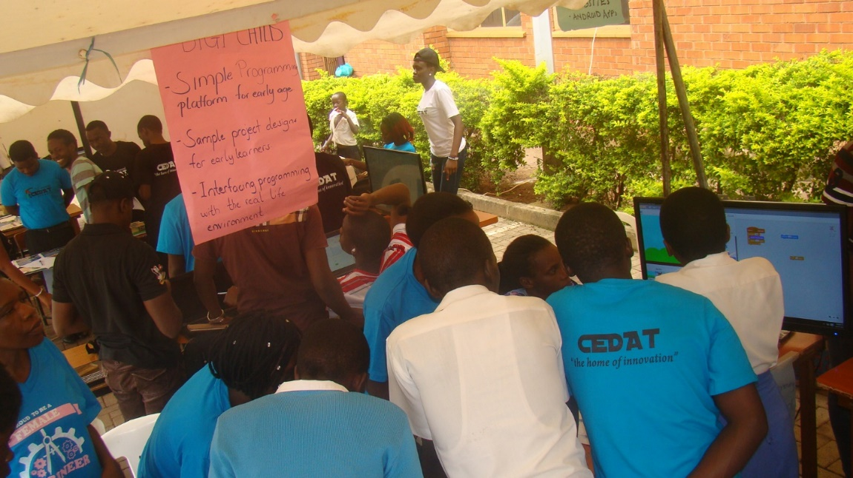
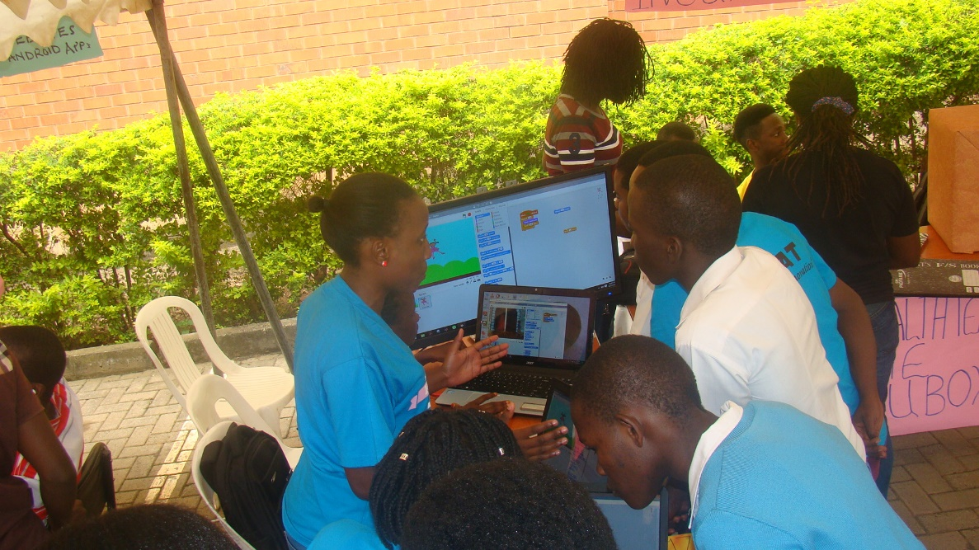

Reference

- Introduction to the Scratch programming language by Brendan Smith from the National University of Ireland Galway.

