Academic Staff Profile Template
Place your professional photo here! (A must-have)  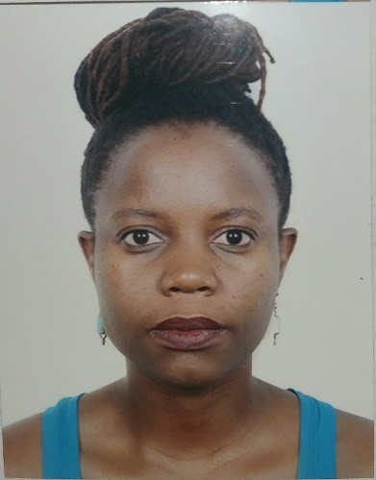  _{Emoji courtesy of WhatsApp} | The size of the photo should not be extremely big almost occupying half a page.
Name: | Ms. Sophie Balunywa
Designation: | Assistant Lecturer
Department: | Department of Construction Economics & Management
Education: | Master Of Business Administration  Bachelor Of Architecture  Construction Management Certificate
Research Interests: | Sustainable Construction  Building Information Modeling
Courses Taught: | Current  Building Types  Sociology  Construction Drawing  Architectural Design Fundamentals  Previously  Strategic Management  Building science
Email: | sbaaza@cedat.mak.ac.ug  sbalunywa@gmail.com
Telephone Number: | +256778-566345
Office Number: | N/A
Publications and/or Research Papers:
- You can list all of them here or even use your researcher identifier.

Other Sections you can have

- Work Experience/Employment Record/Skills/Responsibilities Held
- MAKERERE UNIVERSITY, COLLEGE OF ENGINEERING DESIGN ART AND TECHNOLOGY
Assistant Lecturer (Part Time) 2012- Present
- RESEARCH AND EDUCATION AGENCY,
Program Manager 2019- Present
- SYMBION Uganda,
Architect, Project Coordinator & Lead Revit 5/2018-11/2021
- PROPOSITUM GRP,
Architectural Designer & Project Manager-(Part Time) 05/2013 - 2018
- MAKERERE UNIVERSITY, COLLEGE OF ENGINEERING DESIGN ART AND TECHNOLOGY
Teaching Assistant (Part Time) 12/2011 – 9/2014
- SOUTHERN UNIVERSITY SCHOOL OF BUSINESS
CEES STEM Camp Administrator and Graduate Assistant 08/2015 – 12/2016
- FINICON GROUP (u) LTD,
Graduate Architect 10/2011 - 04/2012

URBAN + RURAL COMMUNITY DESIGN RESEARCH CENTER (U+RCDRC), SUSA
Student Director 08/2009 – 07/2010

- Fellowships and/or Editorial positions

- Professional Associations / Membership
UGANDA SOCIETY OF ARCHITECTS - COPORATE MEMBER ARB NO. 307
- Academic Prizes

- Scholarship Awards

