Increase use of ICT while managing E-Waste, Assoc. Prof. Dorothy Okello
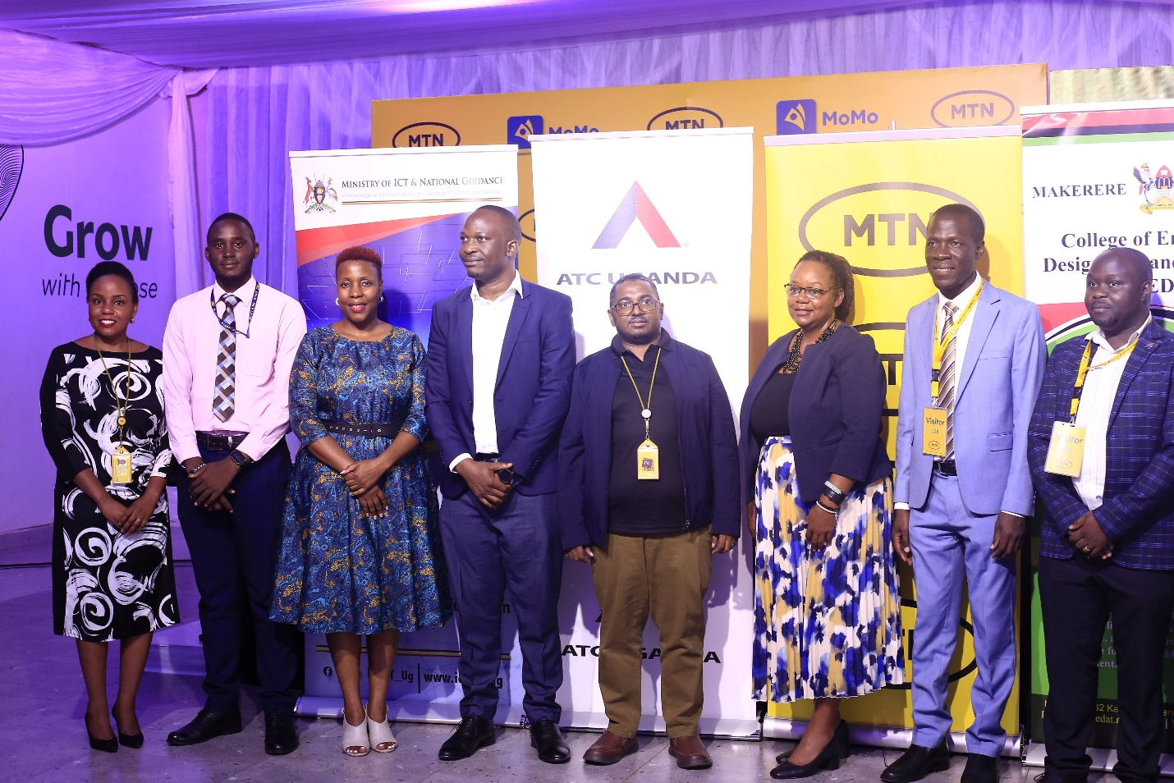

The College of Engineering, Design, Art and Technology (CEDAT) has received a consignment of used electronics and discarded electronic components that will be utilized by engineering students to study, recycle, remodel and rebuild using parts that can still function.
A team from CEDAT led by the Dean School of Engineering Assoc. Prof. Dorothy Okello received the equipment on Tuesday 21st March 2023 at MTN head office. The 390 items included 166 Monitors, 134 Desktops, 90 Laptops estimated to be worth Twenty Million Uganda Shillings.
While receiving the equipment, the Dean highlighted some of the challenges that were getting solved by recycling and re using e- waste that included an increase in the number of computers and laptops for the less privileged to access internet and ICT citing Schools in the rural and underserved areas.
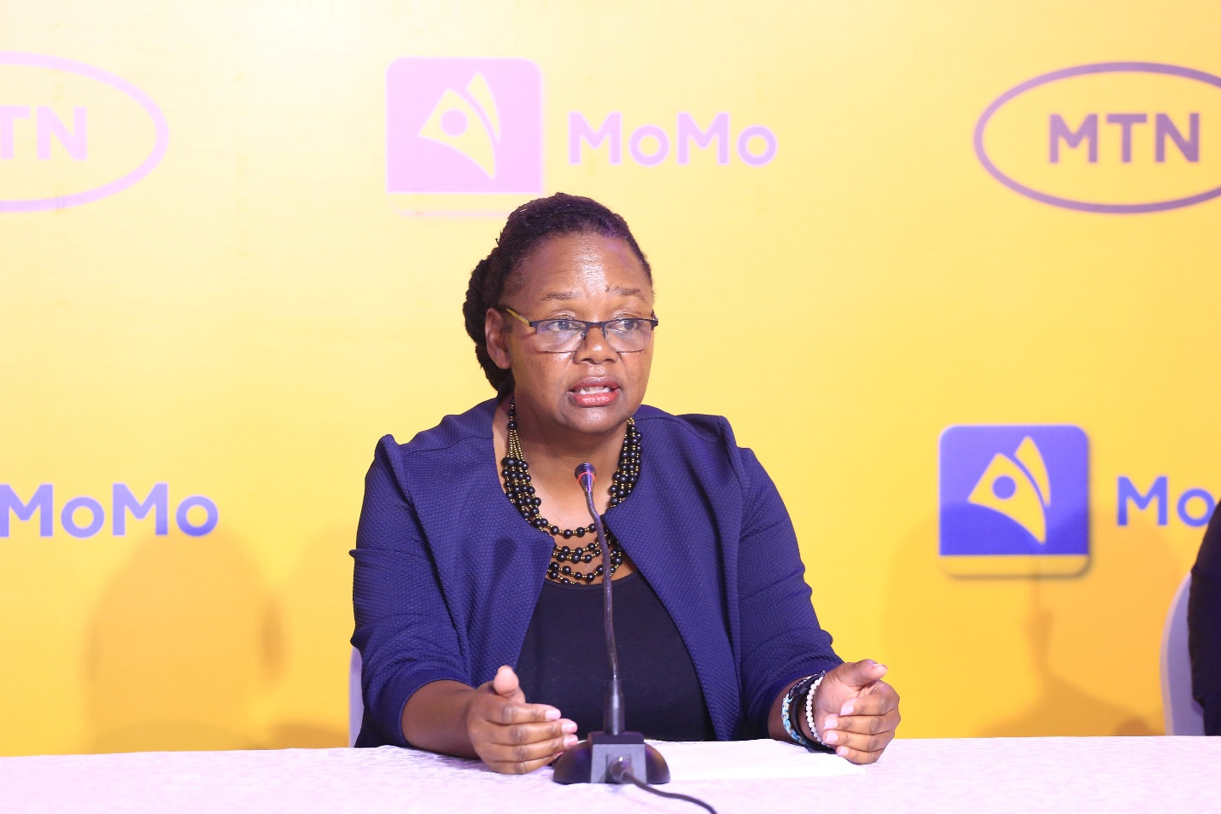
Assoc. Prof. Dorothy Okello, Dean School of Engineering, College of Engineering, Design, Art and Technology, Makerere University.
She noted that in line with the E- Waste Management Policy, 2012 as revised in 2922, the college will be contributing towards proper e waste management given the ever increasing E waste volumes arising from the increased uptake of ICT. The other challenge this intervention will address is related to the danger posed to health and environment if the wastes were not properly disposed of.
Assoc. Prof. Okello explained that the initiative comes in following winning the International Institute of Electrical Engineers (IEEE) award where a similar initiative was presented with emphasis on removing from E- waste the components that could still function in order to rebuild a new computer. She said the college was working with a number of students and that space was availed with basic equipment to start off the initiative.
She noted that the intention was to move the training program beyond the department to other universities as well as develop specialized training programs for proper e- waste management targeted to the private sector.
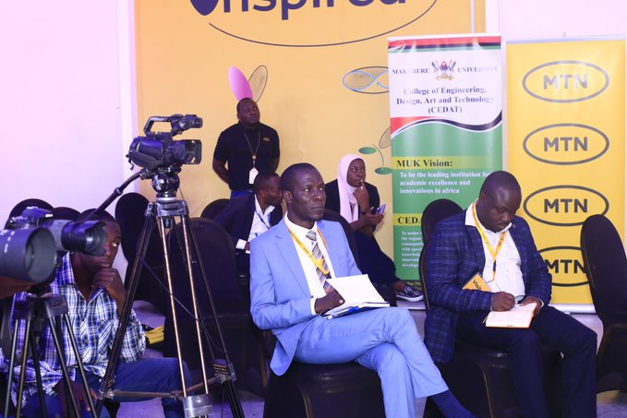
The HoD, Department of Electrical Engineering, Dr. Abubaker Wasswa (L) and Dr. Jonathan Serugunda were in attendance
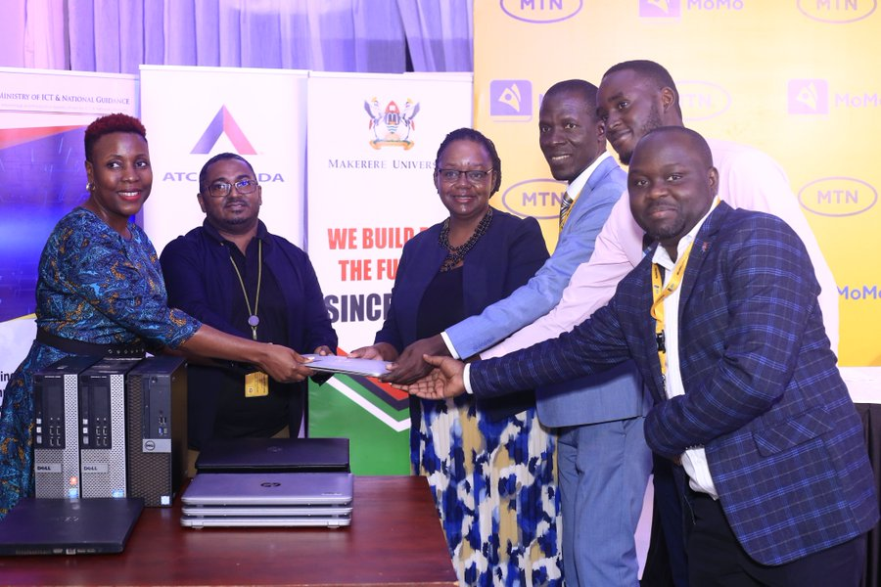
The CEDAT Team receiving used laptops at MTN head officer Tuesday 21st March 2023
She commended MTN Uganda for availing the materials citing the need to have more partnerships for funding as well as providing more e-waste.
‘We are looking at recycling of mobile phones, where MTN is one of the biggest producers’, she said.
She further made a request for raising awareness about the dangers of e-waste to the community and the best ways through which it can get properly disposed of through interventions like awareness campaigns targeted to the communities.
She called on potential partners to come in and aid the process with resources that were needed to facilitate e- waste collection, the delivery of unrecyclable waste to the National E waste management Centre, and the acquisition of socialized lab equipment for recycling.
Prof. Okello pointed out the other key players in this endeavor that include Uganda Communication Commission as the Regulator on waste management as well as the National Environment Management Authority (NEMA).
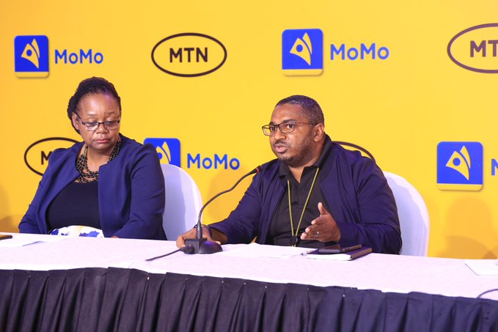
(L) Dr. Yasin Ismael Ramadhan, the Deputy Chief Technical Information Officer at MTN Uganda
Dr. Yasin Ismael Ramadhan, the Deputy Chief Technical Information Officer at MTN Uganda noted that technology was progressing at a very fast pace and hence the accumulation of e waste. The issue of concern was how this waste could be disposed of responsibly and therefore expressed gratitude for the partnership between MTN and Makerere University.
He said due to the changing workplace environment arising out of Covid 19, there was a shift that led to getting rid of desktops and instead bringing laptops to allow flexibility in the way staff work. He noted that there has been an increase in the importation of such equipment like phones and laptops arising from the new technology evolving.
The partnership with the School of engineering will help in the reuse, recycle and repurpose of many of the company’s e waste, he noted, while emphasizing the fact that MTN was very much concerned about conserving the environment as well as mitigating the effects of climate change.

Ms. Masha Walusimbi from American Tower Company (ATC) said MTN partnered with ATC in order to ensure that the innovations around various sites were safe, she said in the same vein, ATC took a decision to partner with Makerere University to ensure that the unrecyclable e waste is well disposed of in order to ensure safety of the population
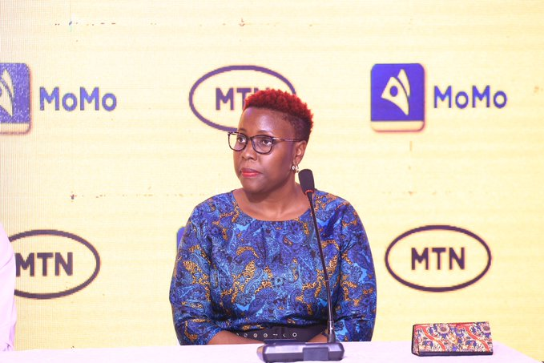
Ms. Masha Walusimbi from American Tower Company expressed their readiness to partner with the School of engineering.
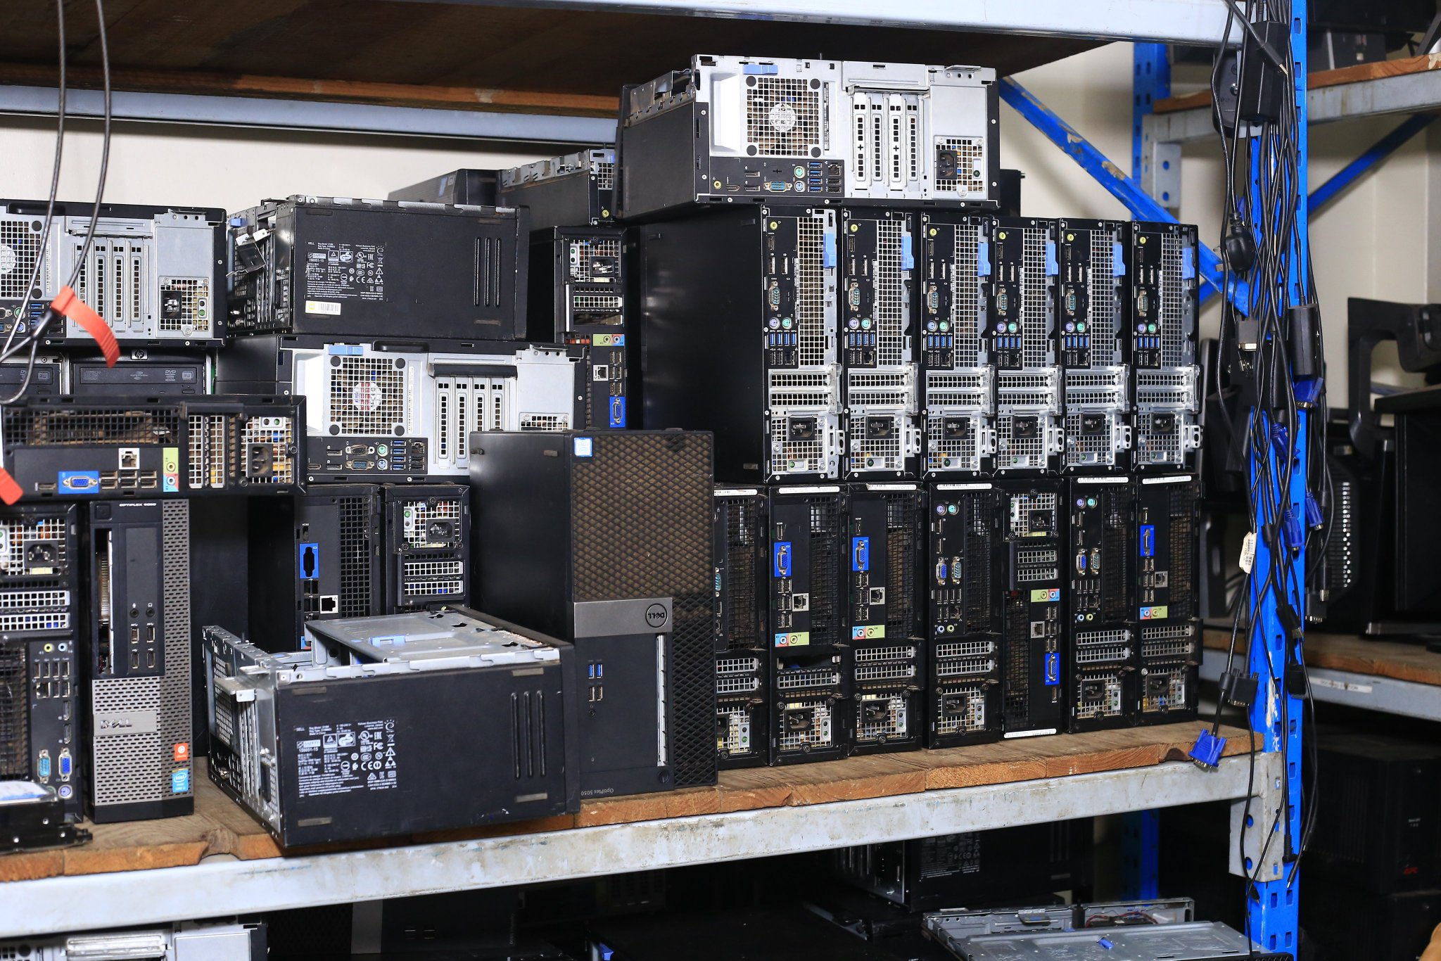
Part of the e-waste consignment that was handed over to CEDAT

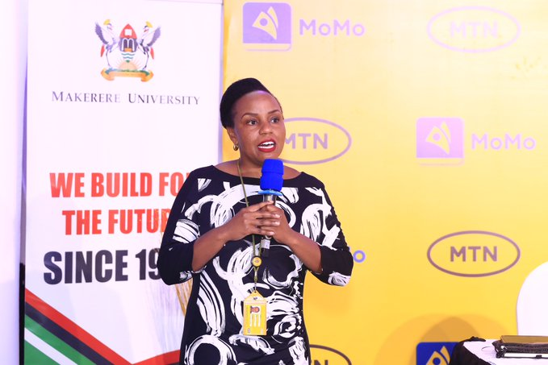
MTN’s Christine Namara noted that technology was changing too fast and that unless the e waste is well disposed of, it will become toxic to soil, water and this could become catastrophic.

A representative of the Ministry of Information and National Guidance, Mr. Emmanuel Kakooza said the country was faced with the challenge of the short replacement cycle of equipment with various companies putting out new equipment. He said the initiative started by the School of Engineering was necessary to avoid dire consequences.
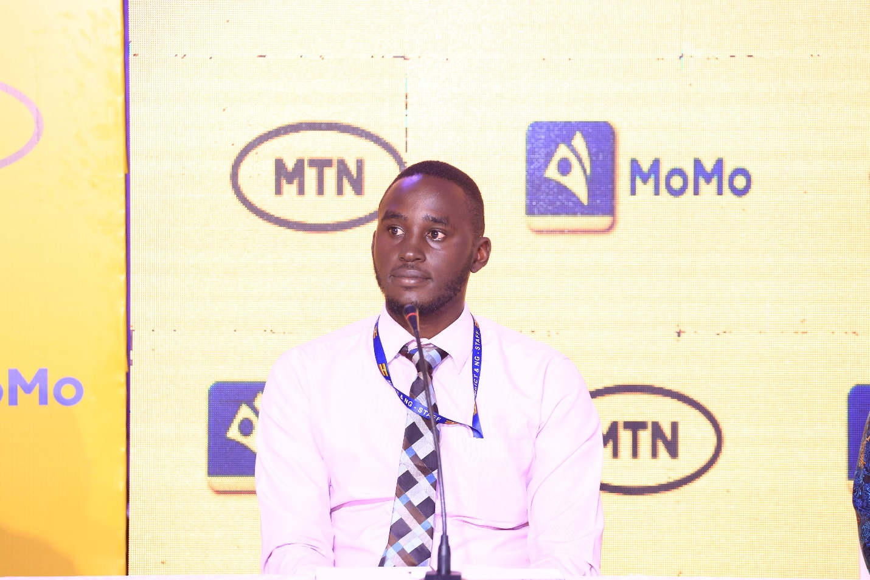
Mr. Emmanuel Kakooza, Ministry of Information and National Guidance
He highlighted a number of steps taken by the Ministry in E waste management and these included the policies, the E waste management facility established in 2021 among others.
He challenges the academic in CEDAT to undertake further studies on what he called, E waste mining which he said could boost the economy.

