**PROMOTION OF HYBRID RENEWABLE ENERGY SYSTEMS TOWARDS ELECTRICITY ACCESS IN UGANDA (PHRE)**

**WORKSHOP REPORT**

MAKER MOVEMENT INSPIRED PRACTICAL COURSE: Applications towards Hybrid Energy systems

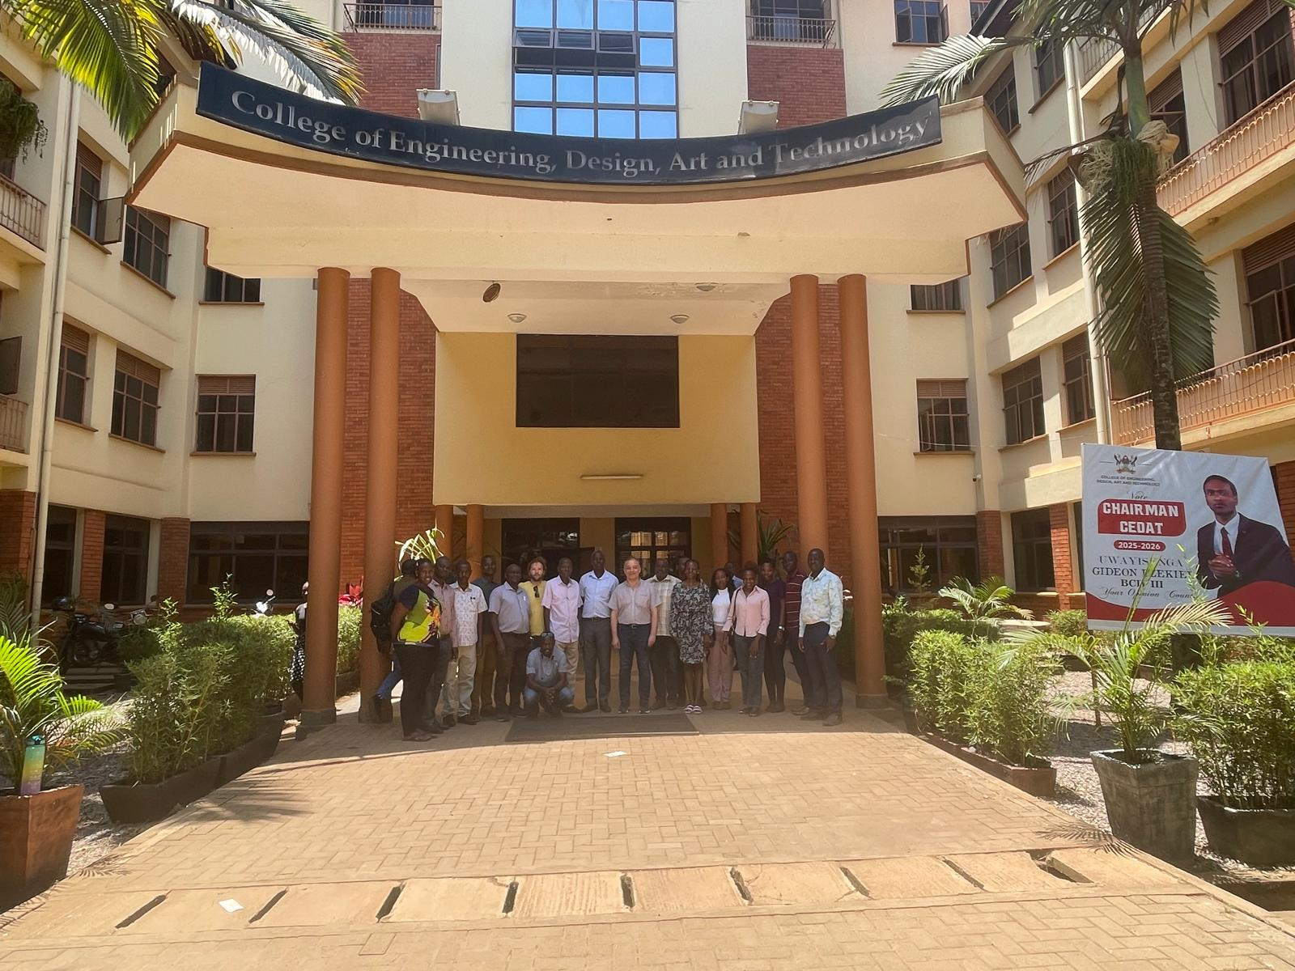

**February 2025**

Table of Contents

INTRODUCTION 3

A VISIT TO KYAMPISI MICROGRID IN AN OFF-GRID VILLAGE, LUWEERO DISTRICT 4

MAKER MOVEMENT INSPIRED PRACTICAL COURSE: Applications towards Hybrid Energy systems. 5

Day 1: Current switching MOSFETS 5

Day 2: Voltage and Current measurement 5

Day 3: Building a battery-Charge Controller 6

CONCLUSION 6

APPENDIX 1 7

# INTRODUCTION

This report highlights the activities of the second practical course workshop that took place at the College of Engineering, Design, Art, and Technology of Makerere University from 22nd to 26th February 2025.The workshop commenced with an introductory session by Dr. Rafat Al Afif, who provided an overview of Hybrid Renewable Energy Systems. His session set the stage for the Maker Movement’s practical course and focused on two key areas:

1. Dr. Rafat Al Afif discussed strategies to maximize biogas production and the challenges associated with integrating it into hybrid energy systems. Solutions to improve efficiency and feasibility were also explored. This session took place on the first day of the workshop (22nd February 2025).

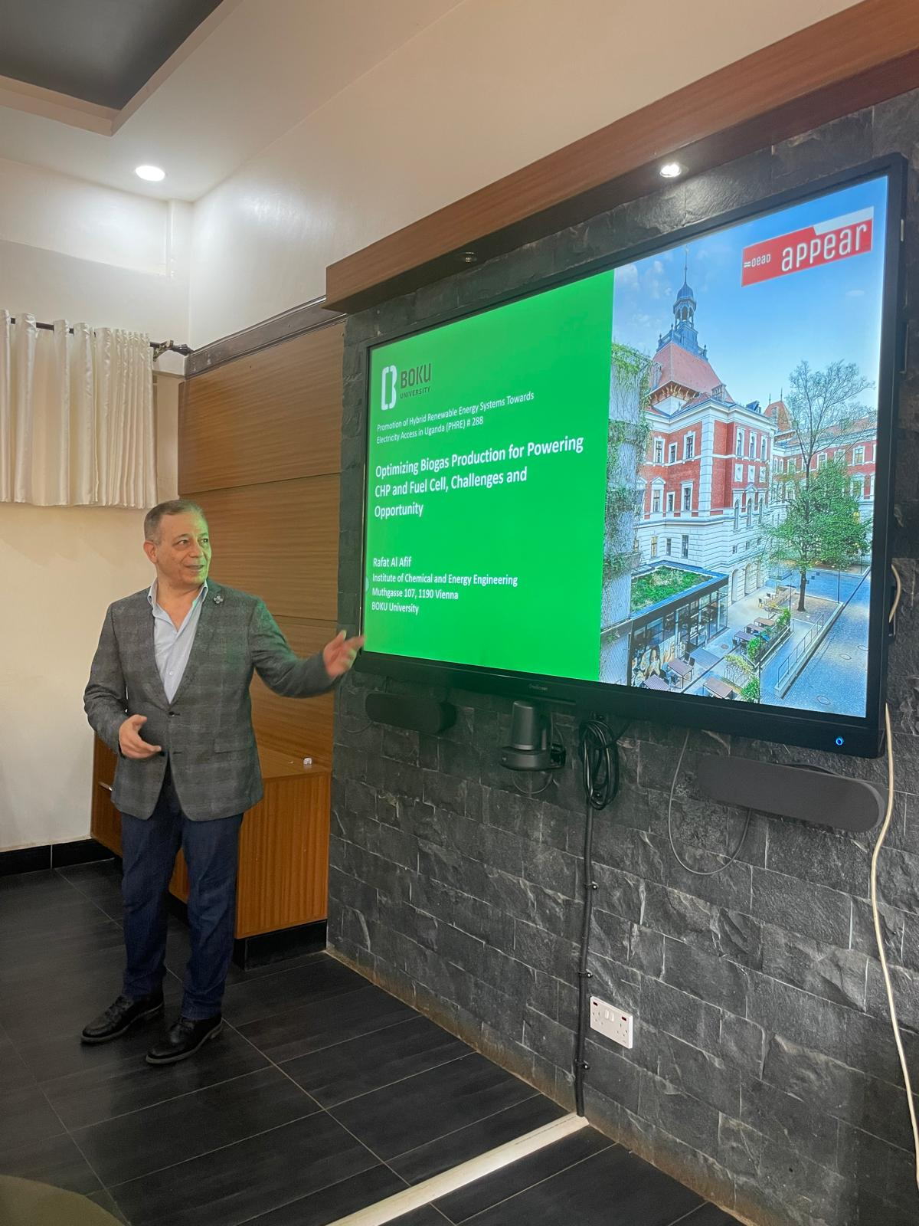

1. Improving the efficiency of Hybrid RE systems.

* This session focused on the proper configuration and sizing of hybrid system components, including PV arrays, battery banks, charge controllers, and inverters. The importance of ensuring the optimal performance of key system components, particularly charge controllers, was emphasized.
* Various types of charge controllers were discussed, including:
  1. Hybrid charge controllers
  2. Battery Management Systems (BMS)
  3. Standard charge controllers
  4. Pulse Width Modulation (PWM) controllers
  5. Maximum Power Point Tracking (MPPT) controllers
* The discussion also highlighted the necessity of charge controllers in preventing battery overcharging and undercharging, as well as the associated risks.

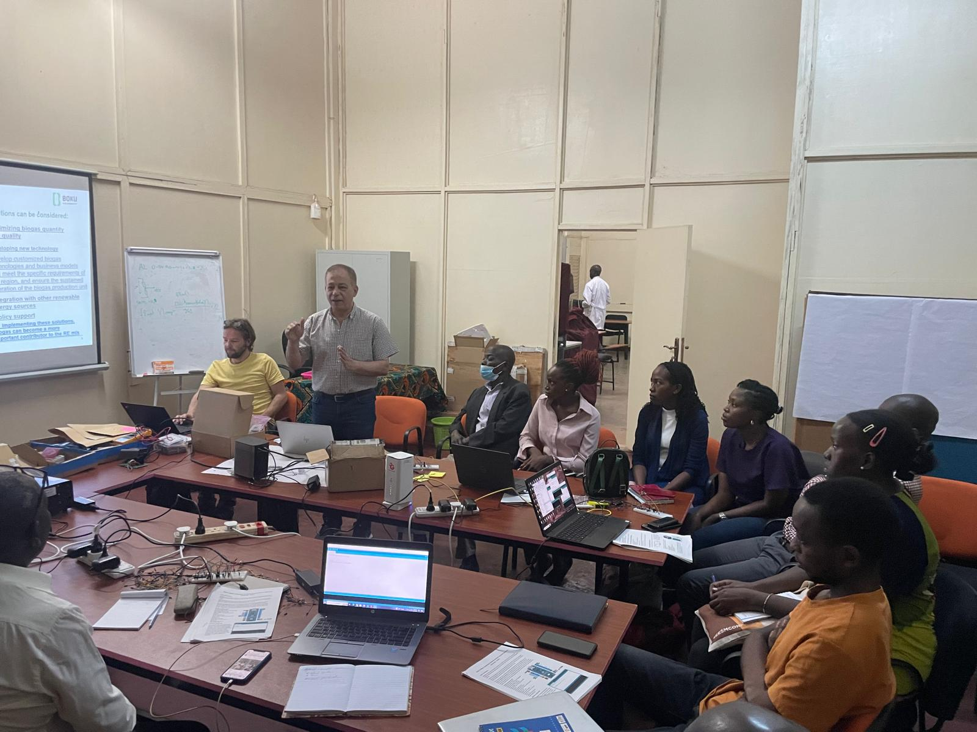

# A VISIT TO KYAMPISI MICROGRID IN AN OFF-GRID VILLAGE, LUWEERO DISTRICT

Dr. Rafat visited the mini grid in Kyampisi, Luweero with a sole purpose of understanding energy related challenges of this rural area in Uganda and how the mini-grid has impacted the lives of the different community members. The 10KW system powers an energy kiosk, machine for moulding briquets, and a water pump.

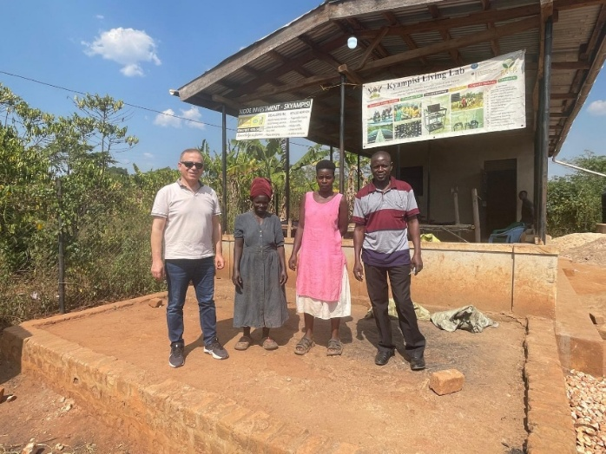

# MAKER MOVEMENT INSPIRED PRACTICAL COURSE: Applications towards Hybrid Energy systems.

This course was conducted over a three-day period. The course was facilitated by Florian and focused on hands-on learning experiences aimed at enhancing participants’ understanding of essential electronic components and their applications in hybrid energy systems. The workshop provided a structured approach to learning through five key tasks, each designed to build on fundamental concepts and practical skills.The tasks were designed to progressively build the participants’ knowledge and skill set, starting with basic switching mechanisms and culminating in the development of a battery charge controller. The tasks covered were as follows:

* Task 1: Current switching with MOSFETs
* Task 2: Measure Voltage:
* Task 3: Measure Current:
* Task 4: Print your measured values to the OLED-Display:
* Task 5: Build a Battery-Charge-Controller:

## Day 1: Current switching MOSFETS

For this task we used an external 12VDC power supply and an IRLZ44 -n-channel MOSFET for simple low-side switching. MOSFETs (Metal-Oxide-Semiconductor Field-Effect Transistors) are critical components in power electronics and energy systems. This task introduced participants to the principles of current switching using MOSFETs and was divided into two subtasks:

* **Subtask A: Switching ON and OFF** Participants learned the fundamental principles of controlling electrical current flow using MOSFETs. Practical exercises involved turning circuits on and off by controlling the MOSFET gate voltage.
* **Subtask B: Pulse Width Modulation (PWM)** Pulse Width Modulation was introduced as a technique for controlling power delivery. Participants explored how varying the duty cycle of a PWM signal can regulate power output in hybrid energy systems.

## Day 2: Voltage and Current measurement

This task focused on equipping participants with the knowledge and skills required to measure voltage accurately in an electrical circuit. Participants worked with sensors and microcontrollers to measure voltage levels, a fundamental aspect of monitoring and managing energy systems. The output was observed on the CRO. Building on this task, participants learned techniques for measuring electrical current. They were introduced to different types of current sensors and their applications in hybrid energy systems.

|  |  |
| --- | --- |
|  |  |

## Day 3: Building a battery-Charge Controller

This was the final task which brought together all the concepts covered in the workshop, guiding participants through the process of designing and implementing a basic battery charge controller. Participants applied their knowledge of MOSFET switching, voltage and current measurement, and data display to develop a functional system capable of regulating battery charging in a hybrid energy setup. Two groups set up the circuit on the breadboard while the other two groups built the prototype on protoboards.

|  |  |
| --- | --- |
|  |  |

# CONCLUSION

The workshop provided a valuable hands-on learning experience, enabling participants to develop practical skills applicable to hybrid energy systems. Through structured tasks, participants gained insights into electronic switching, power regulation, and system monitoring. By the end of the three-day course, attendees had acquired the foundational knowledge necessary to apply these concepts to real-world energy solution

# APPENDIX 1

|  |  |
| --- | --- |
|  |  |
|  |  |
|  |  |
|  | |